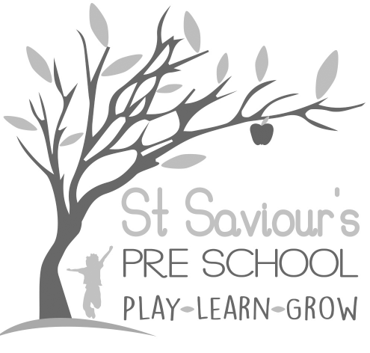
6.0 HEALTH

6.1 ADMINISTERING MEDICINES

Written by: Claire Toms and Tina Alder Date: 1.09.22 – reviewed 28.5.25

Policy statement
While it is not our policy to care for sick children who should be at home until they are well enough to return to the setting, we will agree to administer medication as part of maintaining their health and well-being or when they are recovering from an illness. We follow the statutory guidance in the EYFS 2025 regarding administration of medication and management of children with medical needs.
We ensure that where medicines are necessary to maintain the health of the child, they are given correctly, in accordance with legal requirements and best practice guidance, and that records are kept accurately.
Oral medicines will only be administered, if necessary, with a written instruction from the parent/carer. We reserve the right to refuse to give medicine and to ask the parent/carer to administer it themselves.
The manager or deputy is responsible for the correct administration of medication to children. This includes ensuring that parent consent forms have been completed, medicines are stored correctly, and records are kept according to procedures.

Procedures
- Children taking prescribed medication must be well enough to attend the setting.
- We usually only administer medication prescribed for the child by a doctor or other medically qualified professional. It must be in-date and prescribed for the current condition.
- A child’s prescribed medicine is stored in its original container, in a box labelled with the child’s name and photograph, and is inaccessible to children. On receiving the medication, the practitioner checks that it is in date and prescribed specifically for the current condition.
- Parents must sign a consent form giving written permission for the administration of medication.

The consent form contains:
- Full name of child and date of birth
- Name of medication and strength
- Who prescribed it
- Dosage and times to be given in the setting
- Method of administration
- How the medication should be stored and its expiry date
- Any possible side effects that may be expected
- Signature of the parent/carer, printed name, and date

- The administration of medicine is recorded accurately in our medication record book each time it is given and is signed by the person administering the medication.

The medication record book records:
- Name of the child
- Name and strength of the medication
- Name of the doctor that prescribed it
- Date and time of the dose
- Signature of the person administering the medication
- If the administration of prescribed medication requires medical knowledge, we obtain individual training for the relevant member of staff from a qualified health professional.
- No child may self-administer. Where children are capable of understanding when they need medication (e.g., inhalers for asthma), they are encouraged to inform their key person. Staff remain responsible for monitoring and administering as required.

Storage of medicines
- All medication is stored safely in a cupboard out of children’s reach, in a named plastic box with a photograph of the child.
- The manager/deputy is responsible for ensuring medicine is handed back at the end of the day to the parent/carer.
- For some conditions, medication may be kept in the setting to be administered regularly or as required. The manager will check that any medication held in the setting is in date and return any out-of-date medication to the parent/carer.

Children with long-term medical conditions
- Staff receive training in a basic understanding of the condition and in the safe administration of the child’s medication.
- An Individual Health Plan (IHP) is drawn up with the parent/carer, outlining:
  - The key person’s role
  - Information to be shared with other adults caring for the child
  - Measures to be taken in an emergency
- Parents receive a signed copy of the IHP, which is also signed by the staff members involved.

